DATABASE DESIGN USING ER DIAGRAM

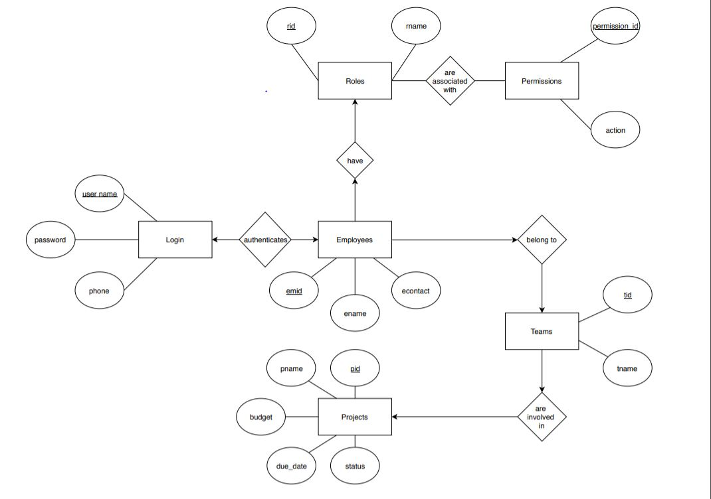

ER DIAGRAM EXPLANATION

An Entity-Relationship model(ER model) or ER diagram is a type of flowchart that illustrates how entities related to each other within a system.ER diagrams are used to model and design relational databases.

This ER diagram represents the model of project management. The entity relationship diagram of project management shows how the project can be done by the team members and employees. It describes the relationship between Employees and Teams, Teams and Projects. The main entities in this ER diagram are : Employees, Roles, Teams, Projects, Permissions, Roles.

ENTITIES:

Project management system and their attributes are:

* Employees :Attributes of Employees are emid, ename ,econtact
* Projects :Attributes of Projects are pid, pname, budget, due_date, status
* Teams :Attributes of Teams are tid, tname
* Roles :Attributes of Roles are rid, rname,
* Permissions: Attributes of Permissions are permission_id,action
* Login:Attributes of Login are username,password,phone

RELATIONSHIPS

* Each entity contains primary key and unique keys.
* All entities Projects,Teams,Roles,Permissions,Login are normalized to reduce duplicacy of records.

DATABASE DESIGN IN RELATIONAL MODEL:

create table Employees ( emid number(10) primary key, fname varchar2(50), lname varchar2(50), econtact number(20));

create table Employees ( emid number(10) primary key, fname varchar2(50), lname varchar2(50), econtact number(20));

create table Login ( userid varchar2(20) primary key, password varchar2(50), phone number(20));

create table Projects ( pid number(10) primary key, pname varchar2(50), budget number(12,2), deadline date, status varchar2(20));

create table Roles ( rid number(10), rname varchar2(20), primary key(rid)); create table Permissions ( permission_id number(10), action varchar2(50), primary key(permission_id));

create table Teams ( tid number(10), tname varchar2(50), primary key(tid));

create table Authenticate ( userid varchar2(20), emid number(10), primary key(userid,emid), foreign key(userid) references Login(userid), foreign key(emid) references Employees(emid));

create table Have ( emid number(10), rid number(10), primary key(emid,rid), foreign key(emid) references Employees(emid), foreign key(rid) references Roles(rid));

create table Associates ( rid number(10), permission_id number(10), primary key(rid,permission_id), foreign key(rid) references Roles(rid), foreign key(permission_id) references Permissions(permission_id));

create table Belongs ( emid number(10), tid number(10), primary key(emid,tid), foreign key(emid) references Employees(emid), foreign key(tid) references Teams(tid));

create table Involve ( tid number(10), pid number(10), foreign key(tid) references Teams(tid), foreign key(pid) references Projects(pid));

insert into Employees values(101,'Dave','Richards',8919427588);

insert into Employees values(102,'Yasaswi','Yasaswi',8919427589);

insert into Employees values(103,'Abhishikth','Chandaka',8919427598);

insert into Employees values(104,'Vivek','Murahari',8919427599);

insert into Employees values(105,'Pavani','Bendi',8919427501);

insert into Employees values(106,'Meghana','Lakshmi',8919427502);

insert into Employees values(107,'Swetha','Anne',8919427503);

insert into Employees values(108,'Hanuman','Sai',8919427504);

insert into Employees values(109,'Yugesh','Adhikarla',8919427505);

insert into Employees values(110,'Shashank','Komal',8919427506);

insert into Employees values(111,'Sudheer','Paul',8919427507);

insert into Employees values(112,'Chamanti','Aki',null);

insert into Login values('user101','a1b2c3d4',9052182555);

insert into Login values('user102','a1b2c3d5',8919427589);

insert into Login values('user103','a1b2c3d6',8919427598);

insert into Projects values(401,'Project Management',1000,'29-sep-2019','Ongoing');

insert into Projects values(402,'Nature Basket',10000,'29-sep-2019','Not started');

insert into Projects values(403,'Hotel Management',5000,'29-sep-2019','Ongoing');

insert into Projects values(404,'Blood donation',100000,'29-sep-2019','Not Started');

insert into Roles values(201,'Team Leader'); insert into Roles values(202,'Team Member');

insert into Roles values(203,'Project Manager');

insert into Permissions(permission_id,action) values(301,'Write');

insert into Permissions(permission_id,action) values(302,'Read,Write');

insert into Permissions(permission_id,action) values(303,'Full');

insert into Teams values(501,'Team 1'); insert into Teams values(502,'Team 2');

insert into Teams values(503,'Team 3'); insert into Authenticate values('user101',101);

insert into Authenticate values('user102',102);

insert into Authenticate values('user103',103);

insert into Have values(101,201);

insert into Have values(102,202);

insert into Have values(103,202);

insert into Have values(104,202);

insert into Have values(106,201);

insert into Have values(105,202);

insert into Have values(107,202);

insert into Have values(108,202);

insert into Have values(101,202);

insert into Have values(109,201);

insert into Have values(110,202);

insert into Have values(111,202);

insert into Have values(112,202);

insert into Associates values(201,302);

insert into Associates values(202,301);

insert into Associates values(203,303);

insert into Belongs values(101,501);

insert into Belongs values(102,501);

insert into Belongs values(103,501);

insert into Belongs values(104,501);

insert into Belongs values(105,502);

insert into Belongs values(106,502);

insert into Belongs values(107,502);

insert into Belongs values(108,502);

insert into Belongs values(109,503);

insert into Belongs values(110,503);

insert into Belongs values(111,503);

insert into Belongs values(112,503);

insert into Belongs values(101,502);

insert into Involve values(501,401);

insert into Involve values(502,402);

insert into Involve values(503,403);

1)List all the employees

Ans:select * from employees;

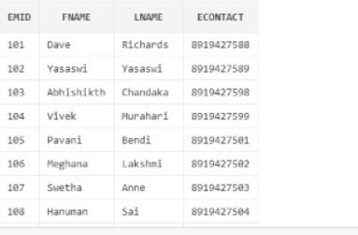

2)select the employee name who does not have contact number

Ans:select fname,lname from employees where econtact is null;

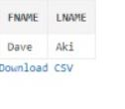

3)find the team id’s who are involved with pid=401.

Ans:select tid from Involve where pid=401;

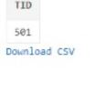

4)find the employee id who belong to tid=501

Ans:select emid from belongs where tid=501;

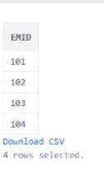

5)find the team id of employee with emid=105.

Ans:select tid from belongs where emid=105;

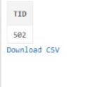

6)find the employee id authenticates with username "user101"

Ans:select emid from authenticate where userid='user101';

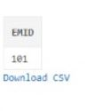

7)find the rid having a role name='Project Manager'

Ans:select rid from Roles where rname='Project Manager';

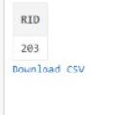

8)find rname of a role with id=202.

Ans:select rname from roles where rid=202;

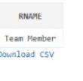

9)find permissions ids associated with role id=201

Ans:select permission_id from associates where rid=201;

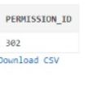

10)find project id of project name=”hotel management”

Ans:select pid from projects where pname='Hotel Management';

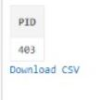

11)find role ids have employee id=104

Ans:select rid from have where emid=104;

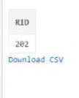

12)find the names of employees whose contact starts with 8.

Ans:select fname,lname from employees where econtact like '8%';

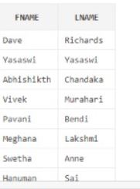

13)find employee having multiple roles.

Ans:select * from Have H1,Have H2 where H1.emid=H2.emid and H1.rid<>H2.rid;

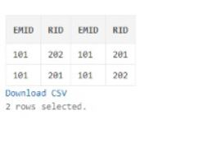

14)find all team leaders.

Ans:select emid from Have where rid=201;

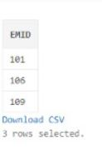

15) find all team members

Ans:select emid from Have where rid=202;

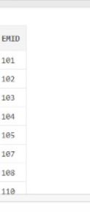

16) find project with budget > 1000

Ans:select pid from Projects where budget>1000;

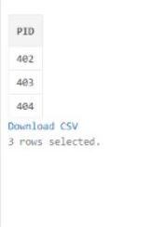

17) find projects that are ongoing.

Ans:select pid from Projects where status like 'Ongoing';

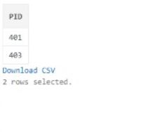

18) find number of projects

Ans:select count(pid) from Projects;

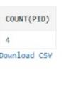

19) find employees with different registered and recovery contact numbers.

Ans:select emid from Employees,Login where econtact<>phone;

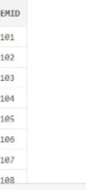

20) find employees with same registered and recovery contact numbers.

Ans:select emid from Employees,Login where econtact=phone;

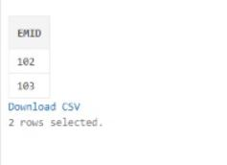

21) find userid having no recovery mobile

Ans:select userid from Login where phone is null;

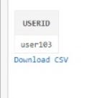

22) find employees with same fname.

Ans:select E1.fname,E1.lname from Employees E1,Employees E2 where E1.fname=E2.fname and E1.emid<>E2.emid;

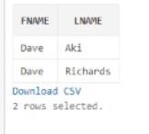

23) find team id of team named 'Team 2'.

Ans:select tid from Teams where tname='Team 2';

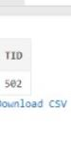

24) find due date of project named 'Project Management'.

Ans:select deadline from Projects where pname='Project Management';

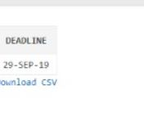

25) find projects that are not yet started.

Ans:select pid from Projects where status like ‘Not started’;

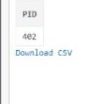

26) find projects with budget >1000 and is ongoing.

Ans:select pid from Projects where budget>1000 and status like ‘Ongoing’;

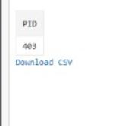

27) Find number of days left for project named project management.

Ans:select deadline-sysdate from Projects where pname=‘Project Management’;

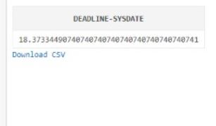

28) Find projects with due date as end of September 2019

Ans:select pid from Projects where deadline < last_day(‘01-sep-2019’);

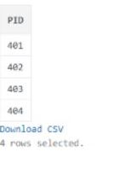

29) Find projects with today as due_date.

Ans:select pid from Projects where deadline like sysdate;

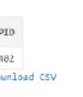

30) Find employees whose contact ends with 9

Ans:select emid from Employees where econtact like ‘%9’;

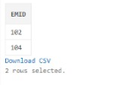

31)Find names of Employees who is a Team Leader.

Ans:select fname,lname from Employees where emid in(select emid from Have where rid in(select rid from Roles where rname='Team Leader'));

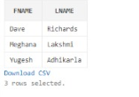

32)Find names of Employees of same team.

Ans:select fname,lname from Employees where emid in(select emid from Belongs where tid in(select tid from Teams where tid=501));

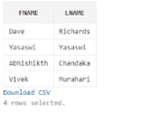

33)Find names of Employees working on Project Management.

Ans:select fname,lname from Employees where emid in(select emid from Belongs where tid in(select tid from Involve where pid in(select pid from Projects where pname='Project Management')));

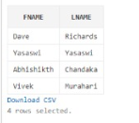

34)Find names of Employees without recovery phone.

Ans:select fname,lname from Employees where exists(select emid from Authenticate where exists(select userid from Login where phone is null and Authenticate.userid=Login.userid) and Employees.emid=Authenticate.emid);

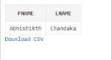

35)Find names of Employees in multiple teams.

Ans:select fname,lname from Employees where exists(select B1.emid from Belongs B1,Belongs B2 where Employees.emid=B1.emid and Employees.emid=B2.emid and B1.emid=B2.emid and B1.tid<>B2.tid);

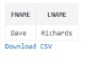

36)Find names of Employees having multiple roles.

Ans:select fname,lname from Employees where exists(select H1.emid from Have H1,Have H2 where Employees.emid=H1.emid and Employees.emid=H2.emid and H1.emid=H2.emid and H1.rid<>H2.rid);

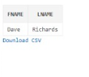

create view EmployeesView as select * from Employees;

select * from EmployeesView;

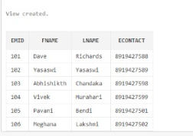

create view ProjectView as select * from Projects;

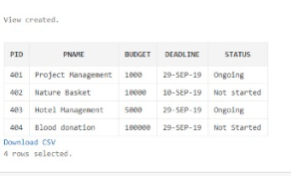

select * from ProjectView

1) Find the total number of projects.

A:

declare

cnt number:=0;

begin

select count(pid) ito cnt from Projects;

end;

C:\Users\home\Desktop\pl1.PNG

2) Find the total budget associated with the projects.

A:

declare

sm number:=0;

begin

select sum(budget) into sm from Projects;

end;

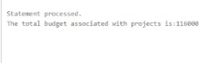

3) Find pid of project whose budget is more than 20000.

A:

declare

prid number:=0;

begin

select pid into prid from Projects where budget>20000;

dbms_output.put_line('Pid of projects with budget more than 20000 is:'||prid);

end;

C:\Users\home\Desktop\pl3.PNG